Nisarg Patel

1. **UML:**

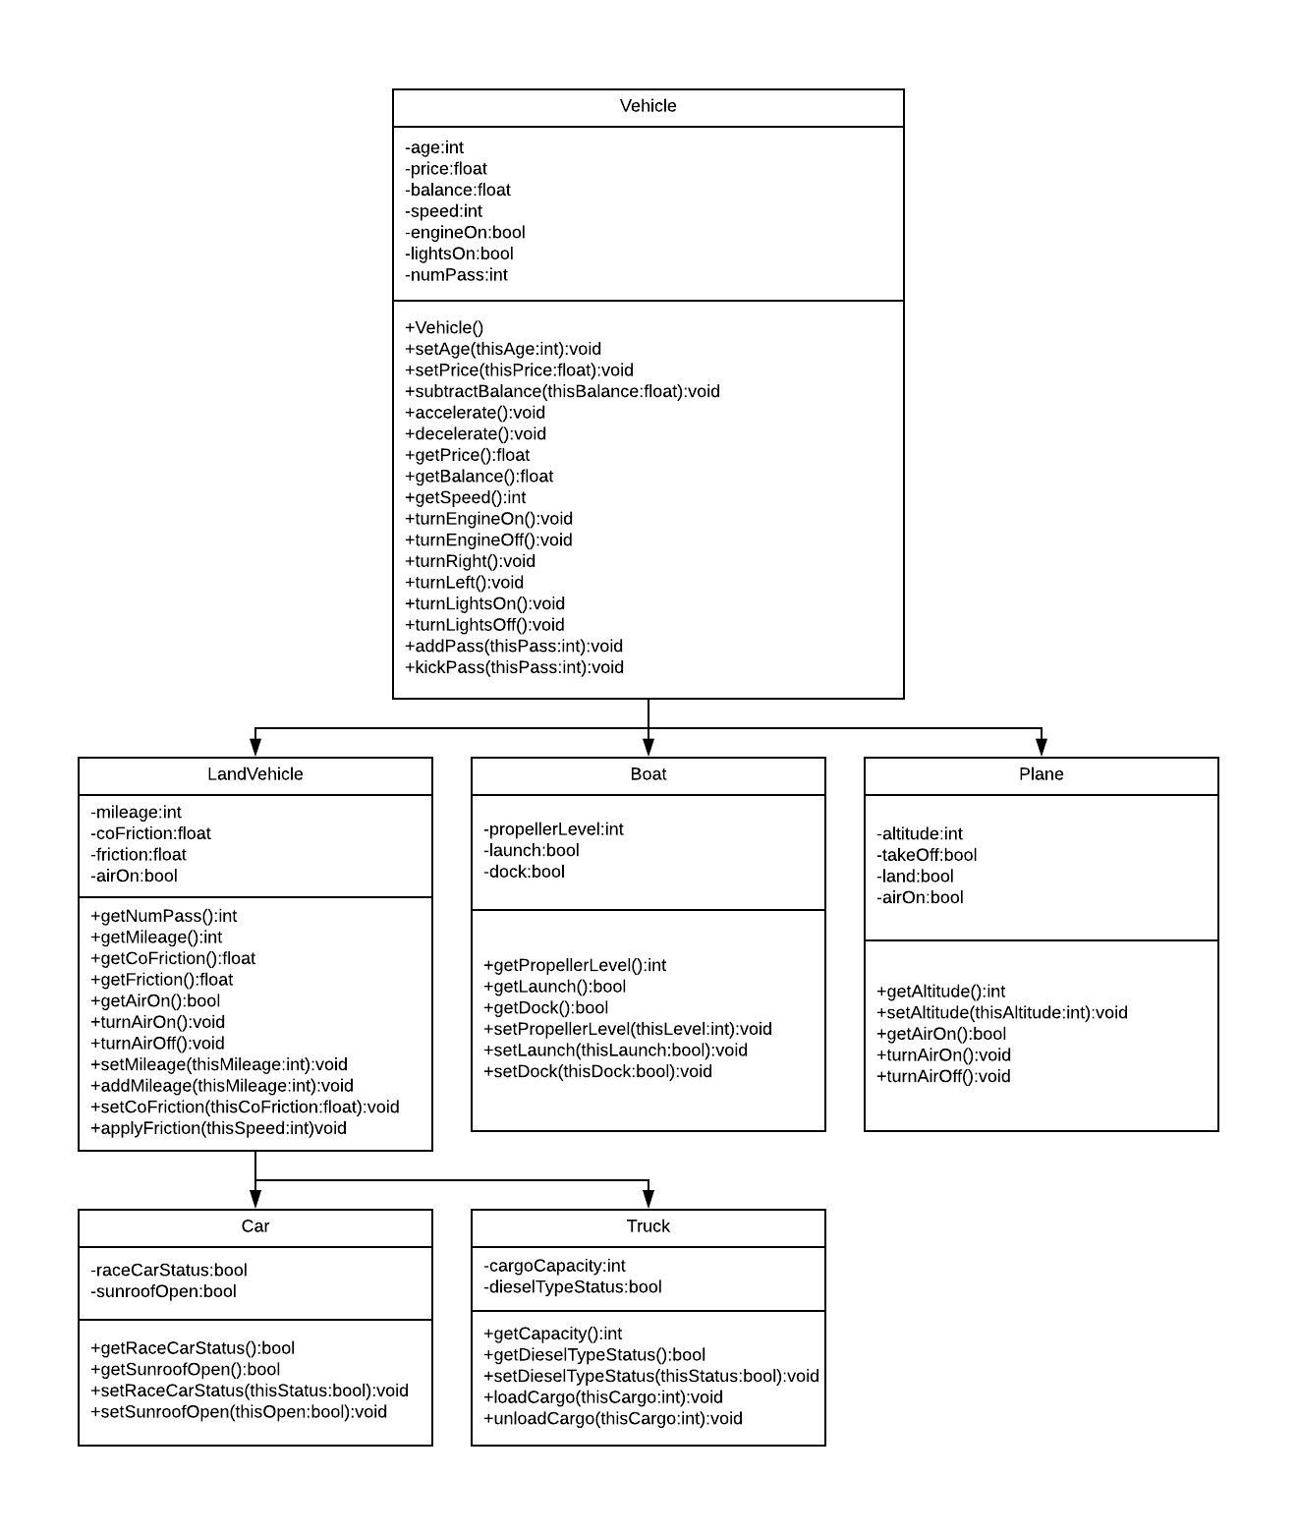

1. **Description of Changes**
   1. Moves: Attributes and functions for number of passengers was moved from car to land vehicle because a truck CAN have passengers, even if it is only 1.
   2. Adds: In Vehicle class, I added attribute balance to calculate user’s money in his or her account each time he or she goes on a trip, price of a trip to store price of each trip, headlights attribute to check if lights are on when vehicle is turned off or on. In Land Vehicle class, I added air conditioning attribute to check if air is turned off when car or truck is turned off or on. In Car vehicle, I added attribute for sunroof to make sure if is turned off when car is turned off. There were no changes in truck class. I also added air conditioning attribute in Plane class. In Boat class, I added propeller level to maintain a specific level to account for the height of the water and to check if it is back to its original position when turning off the boat.
   3. Deletes: I deleted heading from Vehicle class because it does not make any sense to have. I also took out gear attribute from land vehicle class because I will be making it an assumption that the car and truck will be automatic vehicle. Also, from the vehicle class, I took out move function because when I call accelerate or decelerate, it will simply change the speed of vehicle. This way, we can assume the vehicle is moving because speed will be positive.
2. **Drawings of test tours**

